Introduction
These Excel models are a supplement to the USAID report titled, Managing the Climate Impact of Human Waste. The key insights from the analysis of the models and the methodology for developing them are captured in the report.
This document provides an overview of the Excel models, their purpose, and organization.

Overview of the excel models
This package contains the following Excel models:
- 2020_Optimistic case: Estimates the lower-end of emissions from sanitation systems in urban Sub-Saharan Africa (excluding South Africa) in 2020. The value for the optimistic case is calculated by assuming lower values for variables that lacked data, or lacked consensus in literature and among experts.
- 2020_Pessimistic case: Estimates the higher-end of emissions from sanitation systems in urban Sub-Saharan Africa (excluding South Africa) in 2020. The value for the pessimistic case is calculated by assuming higher values for variables that lacked data, or lacked consensus in literature and among experts.
- 2030_Projected case: Estimates emissions from sanitation systems in urban Sub-Saharan Africa (excluding South Africa) in 2030, assuming growth in urban population and achievement of SDG 6.2 by 2030. 2030 emissions are calculated by taking the 2020 pessimistic case value as the base.

Purpose of the Excel models
Current literature on methane emissions in sanitation focuses on wastewater from sewered sanitation systems. However, methane emissions from non-sewered sanitation systems, typical of many low- and middle-income country (LMIC) contexts, are not well-quantified and may be significantly underestimated. Therefore, the Excel models were developed to serve the following purposes:
- Provide a broad estimate of methane emissions in LMICs from unemptied, non-sewered containment facilities, treatment and unsafe discharge of emptied fecal sludge and wastewater, and open defecation.
- Act as a reference point for stakeholders to build emission estimates for their specific contexts/geographies.

Organization of excel models
Figure 1: Sheets within the model
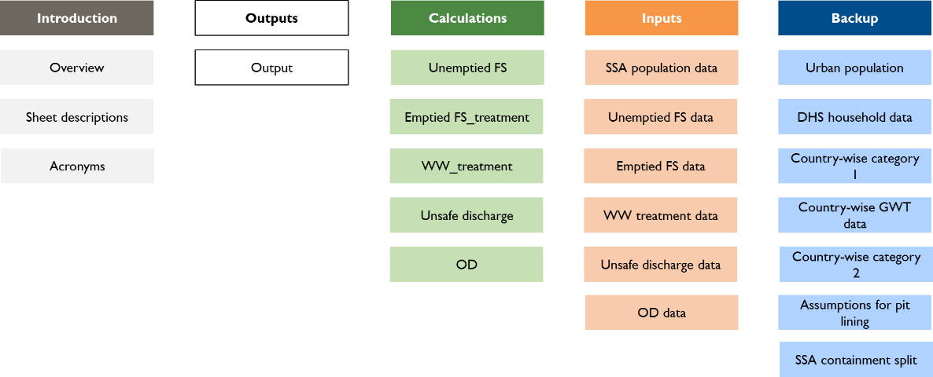
Each model is divided into five categories of sheets (refer to Figure 1). The content of sheets under each category is described below:
- Introduction: Contains 3 sheets providing an overview of the model, a description for each sheet, and a list of acronyms
- Output: Contains 1 sheet providing a snapshot view of key inputs and key outputs for the overall and per capita emissions from each source
- Calculations: Contains 5 sheets providing the breakup and calculation of emissions from each source
- Inputs: Contains 1 sheet providing population data and the conversion factor for the global warming potential of methane, and 5 sheets providing emissions data used for calculating emissions from each source
- Backup: Contains 7 sheets converting source datasets from DHS and groundwater table data for countries in Sub-Saharan Africa into the population data required for calculating emissions from sanitation systems. Backup sheets are different in the Excel model estimating 2030 emissions, as the model sources population split across containment facilities from 2020 pessimistic case and hence, does not contain source sheets for DHS datasets and groundwater table.

SDG 6.2, Sanitation and hygiene: By 2030, achieve access to adequate and equitable sanitation and hygiene for all and end open defecation, paying special attention to the needs of women and girls and those in vulnerable situations.
The backup sheets in the Excel model estimating 2030 emissions are: Urban population 2030, SSA containment split_2020, 2030 containment split_Cat 1, Assumptions for pit lining, and SSA containment split_2030

